**Appendix - A**

**Item-1:**

Sample of Item No. 1 – standard size metal bus stop plates with detailed route information:

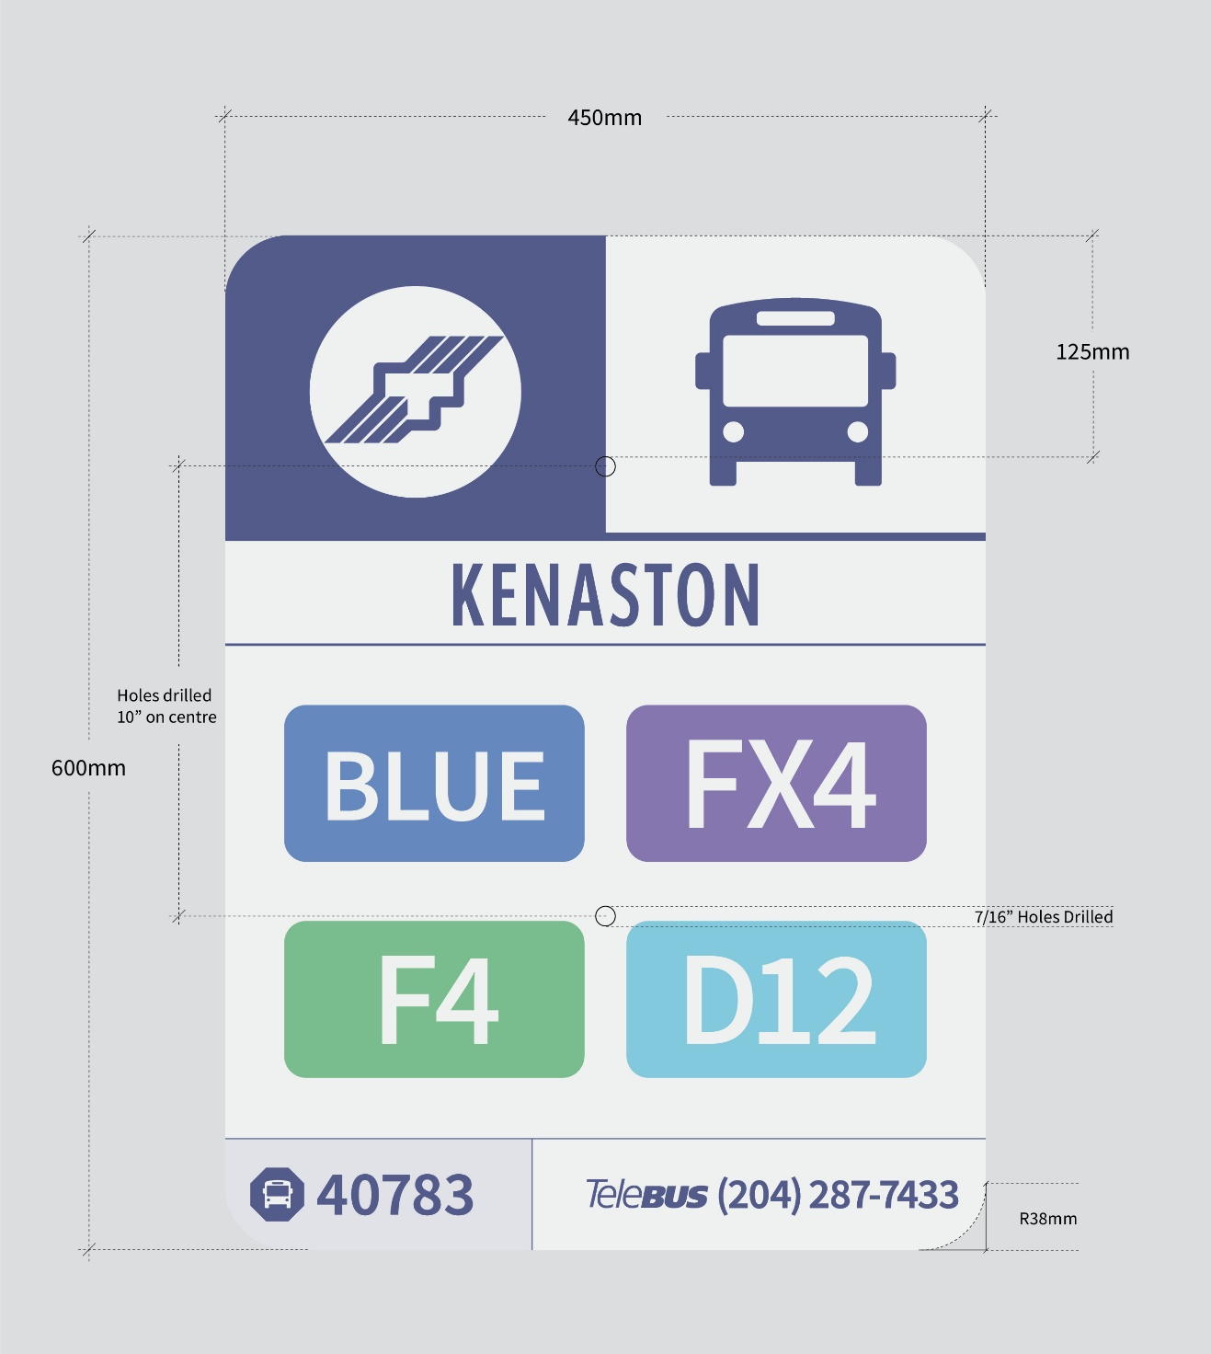

**Item-2:**

Sample of Item No. 2 – standard size metal bus stop plates with blank stop information:

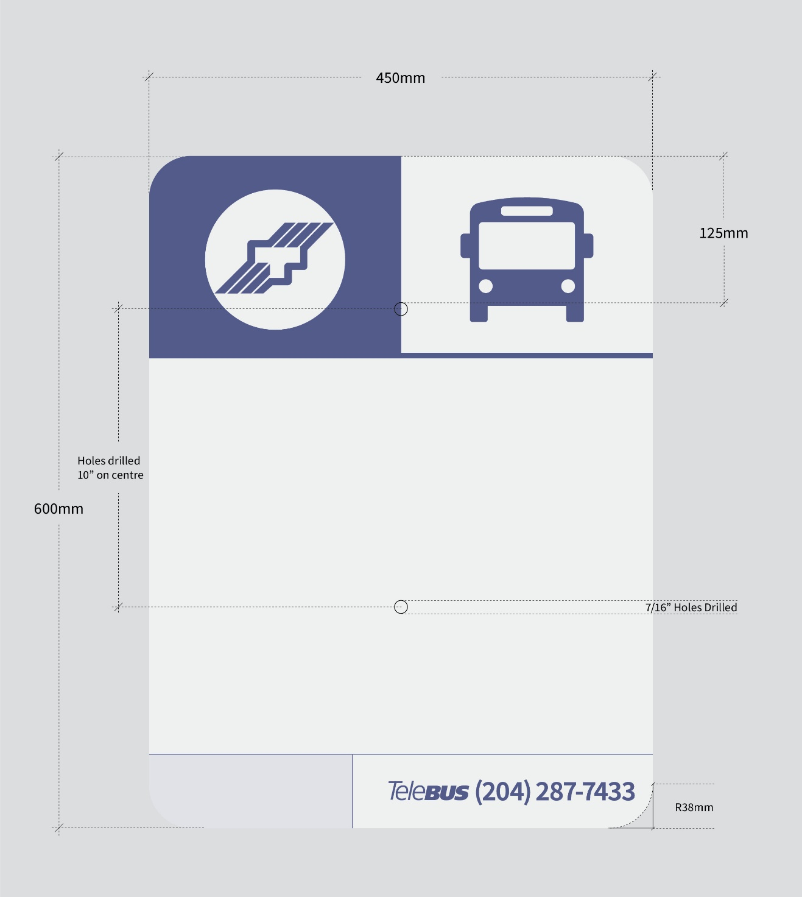

**Item-3:**

Sample of Item No. 3 – large size metal bus stop plate with detailed stop information:

